Beer Name: Blackberry Porter
Brew Date: Apr 21’20
Batch Size: 10 gal
Target OG/◦ 1.067
Amnt lb/kg Ingredient

20 # Pale
2 # Dark Munich
1 # Chocolate
1 # Black Patent
1 # Flaked barley
2 # Wheat Malt
2 # Crystal 60/80
1 tab irish moss

Qt oz/g Hop/Seasoning Time
56 g NB 60min
56 g Cascade 10 min
56 g Cascade 1 min
10 # Blackberrries ( frozen)
Stage Date
Primary:
Racked:
Racked:
Bottled:
Kegged:
Re-Kegged:
Purged:
Charged:

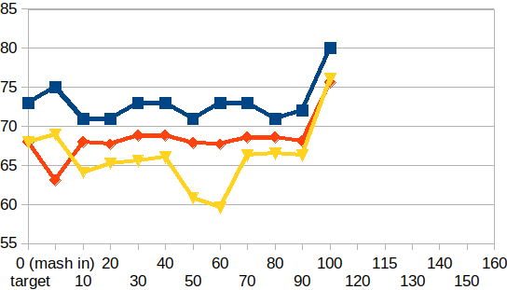
Start Time: 7am
Fill mash tun:
Fill sparge kettle:
Fire burners: 7am
Heat Mash Tun : Target Temp: 68
Heat Sparge Kettle: Target Temp: 73
Target Temp (Mash): 68
Grind grain: 7:40am
sparge temp: 75
Strike Temp: 68
pump temp:69
Temp:63.3
Mash: Duration: 90 minutes
Start:8:10am Finish: 9:40
Heat (to deactivate enzymes)
Target Temp: 75.5
Start: 9:40am
Finish:9:56am
Heat Sparge H20 (Target81◦ )
Sparge:80◦
Start: 9:56am
Finish: 10:29am
Wort collected: full kettle
Boil : Burner On: 10:05
Rolling Boil: 10:55
Hops In: 11:25
Hops In: 12:15
Hops In: 12:24
Duration: 90 min
Start: 10:55
Finish: 12:25 pm
Burner Off:12:25 pm
Rest 15 min
Pump&Chill:Start: 12:40pm Fin: 1:10
OG : 1.070
NottinghamYeast
Irish Moss: 2 tablets
Notes: cook frozen berries night before/use hot plate to
cook blackberries to +84c add campden tablets cool overnite

